Circles
The diameter, d, of a circle is twice the radius, r. Its circumference is d or 2r ( = 3.14 or 22/7- which is approximately 3.14). A central angle has its vertex at the center of a circle, and its measure equals the measure of the arc it intercepts (in degrees). For example, if AOB = 60,
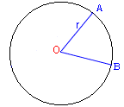
Circumference = 2r =d
AOB = arc AB

then the measure of arc AB is 60, or 60/360 = 1/6 of the circle's circumference. An inscribed angle has its vertex on the circle itself, and its measure is 1/2 of the measure of the arc it intercepts:
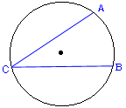
ACB = 1/2 arcAB.

A line that just touches a circle is called a tangent. It is perpendicular to the radius drawn to the point of touching.
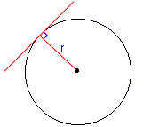
ABC is a right triangle if CB is the diameter. A triangle inscribed in a circle is a right triangle if one of its sides is a diameter. Obviously, A has its vertex on the circle, and it intercepts half of the circle so that A = 180/ 2 = 90.

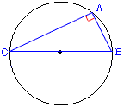
Example 1
What arc length is intercepted by an inscribed angle of 42 on a circle with r = 12 (where = 3.14 = 22/7)?
Solution
The 42 inscribed angle intercepts 1/2(arc) or arc = 84; that is, 84/360 of the circle is intercepted by the angle. The circumference is 2r = 24 so that the arc length is, using = 22/7,
arc length = 84/360 x 24 =
factor out the 12s in 84 and 360, factor 24 into 6 and 4, and convert into 22/7.
(7 x 12)/(30 x 12) x (6 x 4) 22/7 = 88/5 = 17.6

Example 2
A triangle is inscribed in a circle with shorter sides 6 and 8 units long. If the longer side is a diameter, find the length of the diameter.
Solution
A triangle so inscribed (with one side a diameter) is a right triangle. Consequently,
d = 6 + 8 = 36 + 64 = 100; therefore d = 10.

Perimeters and Areas
The perimeter of a figure is the distance around the figure. The perimeter, P, and area, A, of common figures are shown.
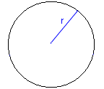  Circle  P= 2r  A=r | Rectangle  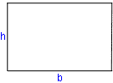  P= 2h + 2b
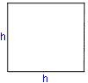  Square  P = 4h  A = h | 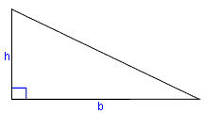  Right triangle  A = bh / 2
Triangle A = bh/2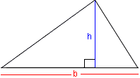 | 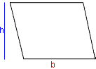  Parallelogram  A = bh

Example 1
What is the radius of a circle if its perimeter is numerically equal to twice its area?
Solution
The perimeter is the same as the circumference = 2r. The area is r, so that
2r = 2r ; therefore, r must equal 1.

Example 2
An automobile travels 2 miles. How many rotations does a 14-inch radius tire make?

Solution
The circumference of a tire is 2r = 2 x 14 = 28 inches. First, make the units commensurate by converting miles to inches (12 inches in a foot, 5280 feet in a mile).
No. of rotations = (2 x 5280 x 12)/28
No. of rotations = (5280 x 12 x 7)/(14 x 22) = (5280 x 3)/11= 1440
In the above, we simplified by canceling out common factors and then multiplied and divided. It is important to first simplify to save time in the final step.

Example 3
A square is inscribed in a circle of radius 10. Determine the ratio of the area of the circle to the area of the square.

Solution
First, sketch the figure. The area of the circle is r = 100. That's easy.

Now let's go over the area of the circle. The diameter is 20, which is also equal to the diagonal of the square. The diagonal of the square is also the hypotenuse of a right triangle inside of the square, a 45-45 triangle.
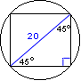
The legs of the triangle are equal so that b = 20/. Since it is a 45/45 right triangle, the legs are equal to the hypotonuse /. The area of the square is the legs squared (20 / ) = 200. The ratio of the areas is
Area circle/Area square = 100/200 =/2

Solids
There are two solids that interest us in preparing for the test. They are the rectangular solid (a box) and a circular cylinder. A cube is a special rectangular box whose sides are all equal. The volume of a box is the product of its three sides: V = bwh. The volume of a circular cylinder is the area of the base times the height: V = rh.
The surface area of a cube is 6 x (area of one side) since all six sides have the same area. The surface area of a cylinder is composed of the top and bottom circular areas and the area around the cylinder. The top and bottom are simply 2 x x r . The area of the side is 2 x x radius x height.
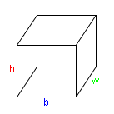  Box  V = bhw | Cylinder  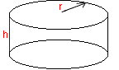  V =rh

Example I
How many liters does it take to fill a box that is 2 m by 20 cm by 20 mm?
Solution
There are 1000 liters in a cubic meter. Hence, we find the volume in cubic meters and multiply by 1000. The volume is
V = bwh
= 2 x 0.2 x 0.02 = 0.008m
1000 liters/m x 0.008m = 8 liters
Example 2
A large box measuring 20 ft x 10 ft and 8 ft high is to be painted, including the top and excluding the bottom. If one quart covers 100 ft of area, how many quarts are required?
Solution
The surface area includes 5 rectangles: top (20 x 10), 2 sides (20 x 8), and 2 more sides (10 x 8). The total area is 680. The number of required quarts is: 680/100= 6.8 or 7 quarts. NOTE: it is assumed the bottom is not painted. This assumption doesn't follow either logically or contextually from the way the problem is stated. If a box were to be painted, I would assume every side would have to be painted. "Including the top" seems redundant, but "excluding the bottom" seems relevant.

Example 3
It takes about 7.5 gallons to fill a volume of one cubic foot. How many gallons are needed to fill a cylinder 2 ft high and 28 inches in radius(=22/7)?
Solution
The volume of a cylinder is the area of its circular base times its height:
V =rh
=22/7
r = 28 inches, or 28/12 feet (divide 28 by 12 to convert) or 7/3 (factor out the 4), r = 49/9
h = 2, height equals 2.
Now let's plug the numbers into the equation: V =rh
= 22/7 x (49/9) x 2 =
cancel out the 7 under 22 and the 49 above 9 and multiply..
= 308 / 9ft
Since it takes 7.5 gallons to fill one cubic foot, multiply the cubic area by 7.5.
= 308/9 * 7.5 gallons = 256 2/3 gallons
Example 4
A gallon of paint covers 400 ft of wall area. How many gallons are required to paint the walls of a building with perimeter 200 ft and height 10 ft (assuming there are no windows)?
Solution
The perimeter is the distance around the building, that is, the length of the rectangles that make up its sides. Since each rectangular side is assumed to be 10 ft high, the total area is
Thus,
A = bh = 200 x 10 = 2000ft
Number of gallons required = 2000/400 = 5
Note: the shape of the building makes no difference here. The building could be circular (think of taking the wrapper off of a bottle to make a rectangle).

Coordinate Geometry
Rectangular Coordinates
A point P is positioned relative to two perpendicular lines, called the coordinate axes. The perpendicular distance from the y-axis to point P is the x-coordinate, the perpendicular distance from the x-axis to point P. The coordinates x and y form an ordered pair (x, y).
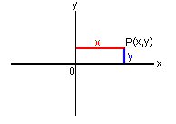
Often, a grid is used to display points relative to the coordinate axes.
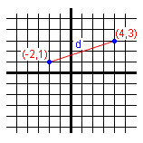 | 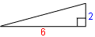
The point (4, 3) is located 4 units from the y-axis to the right and 3 units above the x-axis; the point (-2, 1) is 2 units to the left of the y-axis and 1 unit above the x-axis. The distance, d, between the two points can be found by the Pythagorean Theorem. The horizontal leg is the total distance in the x-direction: 4 - (-2) = 6; the vertical leg is the distance in the y-direction: 3 - 1 = 2. The distance is then
d = 6 + 2=
= 2
Example 1
A square has two corners of a diagonal at (6, 8) and (2,4). What is its area?
Solution
The difference in the x-direction is 6 - 2 = 4 and in the y-direction 8 - 4 = 4. The sides are both of length 4, so that the area is A = 4 x 4 = 16.

Slope Formula:
How do you measure the slant of a line? By definition, it is the ratio of the vertical change to the horizontal change (see figure below).
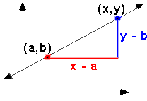
Forming the vertical change over the horizontal change (above) figure results in slope formula (where m is the slope).
m = y - b
x - a
- use this formula to calculate slopes of lines
Example 2
What is the slope of this line?
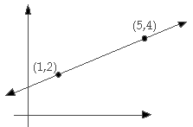
Solution
To solve this problem, plug the digits in the line into the slope intercept equation.
m = y - b
x - a
y= 4, b = 2
x = 5, a = 1
m = (4 - 2)
(5 - 1)
m = 2 = 1
4 2
The slope is 1/2.
Slope Intercept Formula
If you have a formula, such as x - 2y = 4, how do you calculate the slope of the line?
If you want to graph a line, the formula to use is
y = mx + b
In this equation, m is the slope of the line and b is the y-intercept.
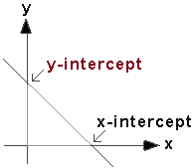
The y-intercept is when x = 0 in an equation.
The x-intercept is when y = 0 in an equation.
The x-intercept is the point where the line crosses the x-axis. It is found by setting y = 0 and solving the resulting equation. The y-intercept is the point where the line crosses the y-axis. It is found by setting x = 0 and solving the resulting equation.
Example 3
Graph the equation 4x - y = 5.
Solution
Try to convert the equation 4x - y = 5 into the format
y = mx + b
4x - y = 5 can be converted into
y = 4x - 5
This means that m = 4 (the slope is 4) and b = -5 (the y-intercept is -5)
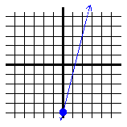
In the above graph, the slope is 4 and the y-intercept is -5.
In the above graph, the blue dot is the y-intercept at (0,-5).
The line slopes up at a rate of 4 up for every 1 across (slope of 4). It intersects lines at (1,-1) and (2,3).

